User Manual

jWebSocket
Remote Shell Demo
1.0

1. Characteristics of the solution
Remote Shell Demo is an application that allows remote control of computers in real time via the web. Making it easier for users to control the resources of a remote computer using a web interface that reflects the results in real time. It is an application that works on WebSocket communication protocol, which provides in conjunction with the framework jWebSocket obtain precise results and high levels of speed and scalability.
The scalability of the servers connections supported by jWebSocket allows high user concurrency. Stress tests performed to a server as a result jWebSocket shed 10 000 concurrent connections without affecting the response time of the application. This element ensures not only perform real-time process but to ensure a high number of users using the same service at the same instant of time, which means that 10 000 people worldwide will have access to Remote Shell Demo.
2. Main Features
1. Allow to connect remotely to a PC.
2. Allow executing commands.
3. Show results in the client side.
4. Select background color.
5. Select the text style.
Remote Shell Demo can be used in various environments but mainly for handle web servers or carry out monitoring of the resources of a remote machine. The reason this application was designed is to show the features that make the framework jWebSocket the best option for developing web applications based on Java / JavaScript that working in real time.
3. Problems to be solved
Problem | Contributions of the solution
Latency in the process of remote control of computers over the Web. | Remote Shell Demo is a Web application that enables you to make the process of remote control of computers in real time using the WebSocket protocol.
4. Glossary
Remote Computer: A remote computer is a regular computer running software that allows the computer to be controlled from a distance, without the need of physical access. The software allows you control over the remote computer, and you can do all the normal tasks with the computer as if it were in front of you.
Real Time in the web: It is possible when the client receives messages from the server without prior request and end users receive updates simultaneously.
WebSocket: It is a technology that provides a bidirectional communication channel and full-duplex over a single TCP socket. This protocol solves the limitations of HTTP, by establishing a full-duplex communication (TCP) between the client and server, replacing the half-duplex communication (HTTP). Is reduced, in large proportions, the network traffic given that WebSocket to establish communication between the client and the server there is only one shipment of 2 bits, eliminating the HTTP headers.
Framework jWebSocket: is a new technology aimed at developing WebSockets based applications that provide high levels of speed, scalability, security and real-time work.
Full-Duplex: Quality of the elements that allow the input and output data simultaneously.
Half-Duplex: Means that the method or protocol for sending information is bidirectional but not simultaneously.

5. Solution Model
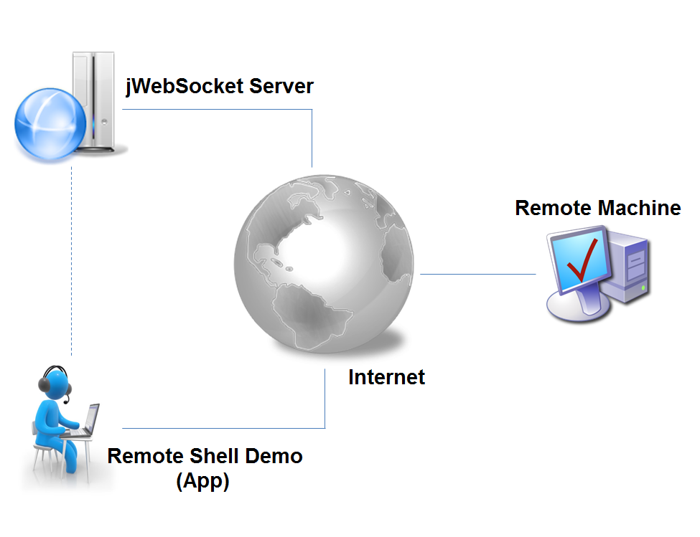

To access Remote Shell Demo client must use a browser that supports WebSocket protocol. Once you authenticate with the server jWebSocket you should enter the data to connect to the remote machine. If the connection is successfully you will be able to interact with the PC remotely via command lines.

7. Requirements for Use
In order to give use to Remote Shell Demo must have Internet access and use any of the browsers that support the communication protocol WebSocket. Some of them are Google Chrome 4+, Safari 5+, Mozilla Firefox 8+, Opera 11+ and Internet Explorer 10+.

8. Roles of the solution

Application User: Interact with the application, can perform all actions that provides the same.

- System operation

Main view: Allows users to authenticate to the server jWebSocket, connecting
to the remote machine and execute commands on it, also allows visual settings to the console.

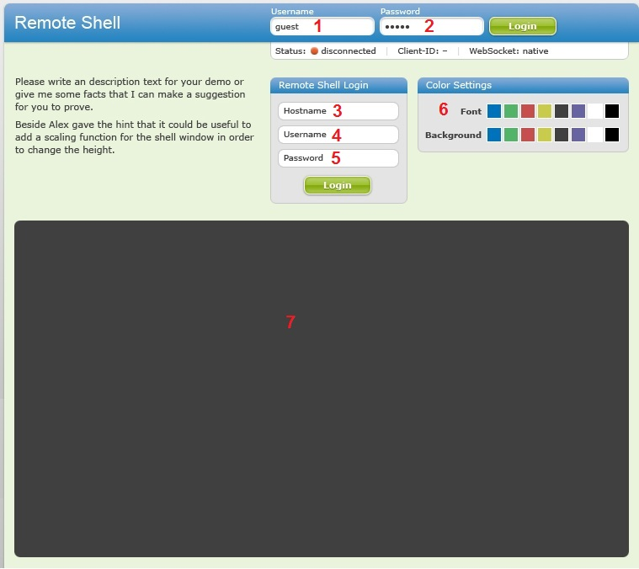

Screen 1
1----- Field where the user enters his ID to access the application.
2----- Field where users enter their password to access the application.

----- Access the application.

3----- Field where the user enters the hostname or the ip of the machine they want to connect.
4----- Field where the user enters the username of the machine to connect to.
5----- Field where the user enters the password to the user of the machine to connect to.

----- Connect to the remote computer.

6----- Area where the user selects settings such as background color and font color.
7----- Area where the user inserts the commands to operate the computer.

- Configurations of the solution
This application does not perform configurations.

- Rules of the solution

R1: If the user enters the username, password or address wrongly the system issues an error message and does not continue with the normal flow. Solution: The user must repeat the procedure for filling the data.

